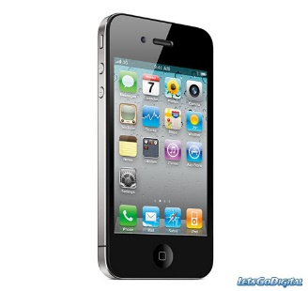
Name
Date
Hour

Are you TOO connected? Take this short quiz and find out!

1. Do you find yourself losing track of time when on your digital devices (computer, laptop, tablet or Smartphone)?
Yes No

2. Do you find yourself mindlessly passing time on a regular basis by staring at your device even when there might be better or more productive things to do?
Yes No

3. Do you find yourself spending more time with ‘virtual friends’ as opposed to real people?
Yes No

4. Has the amount of time you spend on your digital devices and the Internet been increasing?
Yes No

5. Do you secretly wish you could be a little less wired or connected to your devices?
Yes No

6. Do you sleep with your Smartphone ON under your pillow or next to your bed regularly?
Yes No

7. Do you find yourself viewing and answering texts, tweets, and emails at all hours of the day and night—even when it means interrupting other things you are doing?
Yes No

8. Do you text, email, tweet or surf while driving or doing other similar activities that require your focused attention and concentration?
Yes No
CONTINUED
9. Do you feel your use of technology decreases your productivity at times?
Yes No

10. Do you find yourself feeling uncomfortable when you accidentally leave your phone or other Internet digital device in the car or at home, if you have no service, or if it is broken?
Yes No

11. Do you feel reluctant to be without your Smartphone or other digital devices, even for a short time; when you leave the house you ALWAYS have your Smartphone or other digital device with you?
Yes No

12. When you eat meals is your Smartphone always part of the table place setting?
Yes No

Add up your number of YES answers: ________

What do YOU think this means about YOUR level of “digital distraction”?

If you answer YES to more than 3 or 4 of the questions than you might benefit from going on a digital diet and making some small but powerful changes in the way you use your digital devices and technology!

“Digital Distraction Test” from The Center for Internet and Technology Addiction
©2013 Dr. David Greenfield and Attorney David Ryan Polgar

http://virtual-addiction.com/digital-distraction-test/

