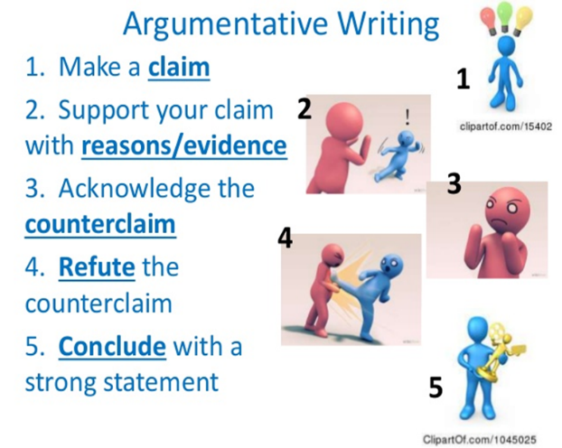

Argument Reading/Writing
“Video Games” Writing Task
Name_________________________________Date_____________________Hour___________
- Write an argument that makes a claim and cites evidence from the readings to support your argument.
- Be sure to Use evidence from all three texts. You can use the infographic as well.
- Remember to write your argument in proper paragraph format, citing the evidence.
______________________________________________________________________________________________________________________________________________________________________________________________________________________________________________________________________________________________________________________________________________________________________________________________________________________________________________________________________________________________________________________________________________________________________________________________________________________________________________________________________________________________________________________________________________________________________________________________________________________________________________________________________________________________________________________________________________________________________________________________________________________________________________________________________________________________________________________________________________________________________________________________________________________________________________________________________________________________________________________________________________________________________________________________________________________________________________________________________________________________________________________________________________________________________________________________________________________________________________________________________________________________________________________________________________________________________________________________________________________________________________________________________________________________________________________________________________________________________________________________________________________________________________________________________________________________________________________________________________________________________________________________________________________________________________________________________________________________________________________________________________________________________________________________________________________________________________________________________________________________________________________________________________________________________________________________________________________________________________________________________________________________________________________________________________________________________________________________________________________________________________________________________________________________________________________________________________________________________________________________________________________________________________________________________________________________________________________________________________________________________________________________________________________________________________________________________________________________________________________________________________________________________________________________________________________________________________________________________________________________________________________________________________________________________________________________________________________________________________________

