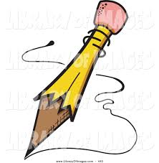
What Should I Say?
Letters to the Author

- Favorite parts of the book
- Characters you like, dislike or connect with in some way
- Events or moments you connect with in the book
- Ask where they came up with the idea for the book
- Ask about certain writing or story decisions
- Ask why they write/how they got started/the process involved
- Ask about the author’s favorite characters or moments
- Discuss how you felt reading the book
- Connections that you made to your own life
- Questions about Setting
- Questions about the ending
- If writing interests you, ask how to get started
- Your ideas for a soundtrack/theme song
- Art that would go along with the book
- Any combination of the above

Girl Stolen by April Henry
https://www.aprilhenrymysteries.com/i-get-letters.html

GATH: Orbiting Jupiter by Gary D. Schmidt https://calvin.edu/directory/people/gary-schmidt

Mr. Gary D. Schmidt
Calvin College
Department of English
Covenant Fine Arts Center 287
Grand Rapids, MI 49546
